***Customer Experience Management in E-Commerce Businesses***

Submitted to the

SAVEETHA INSTITUTE OF MEDICAL AND TECHNICAL SCIENCES

by

C. RAMA DEVI (Reg No:1921724)

Under the guidance of

Dr. BUVANESVARI

Professor



Institute of Computer Science and Engineering

SAVEETHA SCHOOL OF ENGINEERING CHENNAI – 602 105 TAMILNADU, INDIA

# MARCH 2024

**BONAFIDE CERTIFICATE**

This is to certify that the project report entitled “Customer Experience Management In E-commerce Business” submitted by “C. RAMA DEVI (192111724)” to Saveetha School of

Engineering, Saveetha Institute of Medical and Technical Sciences, Chennai, is a record of bonafide work carried out by him/her under my guidance. The project fulfills the requirements as per the regulations of this institution and in my appraisal meets the required standards for submission.

Dr. BUVANESVARI

## Professor

Department of Spatial Informatics

Engineering,

Saveetha School of Engineering

SIMATS, Chennai – 602 105

Internal examiner External Examiner

# TABLE OF CONTENTS

|  |  |  |
| --- | --- | --- |
| **S.NO** | **CONTENTS** | **PAGE NO** |
| 1 | ABSTRACT | 1 |
| 2 | INTRODUCTION | 2 |
| 3 | DESCRIPTION | 4 |
| 4 | SYSTEM REQUIREMENTS | 6 |
| 5 | EXISTING WORK | 8 |
| 6 | PROPOSED WORK | 9 |
| 7 | TECHNOLOGY USED | 10 |
| 8 | USE CASE DIAGRAM | 11 |
| 9 | SOURCE CODE | 12 |
| 10 | SCREENSHOTS(OUTPUTS) | 18 |
| 11 | CONCLUSION | 21 |
| 12 | FUTURE ENHANCEMENT | 22 |
| 13 | REFERENCES | 23 |

## ABSTRACT

|  |
| --- |
| In the rapidly evolving landscape of e-commerce, providing exceptional customer experiences has |
| become a critical factor for business success. Customer Experience Management (CEM) has emerged as a strategic approach for e-commerce businesses to understand, anticipate, and fulfill customer needs |
| and expectations across various touchpoints in the customer journey. This abstract delves into the |
| strategies, challenges, and opportunities associated with CEM in e-commerce businesses. |

|  |
| --- |
| Firstly, effective CEM in e-commerce entails a holistic understanding of customer behavior, preferences, |
| and pain points. Through data analytics and customer segmentation, businesses can gain insights into their target audience and tailor personalized experiences that resonate with individual customers. Personalization algorithms, recommendation systems, and targeted marketing campaigns are instrumental in delivering tailored experiences that enhance customer satisfaction and loyalty.  Moreover, seamless omnichannel integration is paramount in CEM for e-commerce businesses.  Customers expect consistency and continuity across different channels, whether it be website, mobile app, |
| social media, or physical stores. Implementing omnichannel strategies enables businesses to provide a |
| unified experience, allowing customers to transition effortlessly between channels while maintaining context and continuity in their interactions. |
| However, despite the potential benefits, CEM in e-commerce faces numerous challenges. One such |
| challenge is data privacy and security concerns, particularly in light of stringent regulations such as GDPR and CCPA. Balancing the need for personalized experiences with customer privacy rights requires careful data governance and transparency practices to build trust and mitigate risks. |
| Additionally, the dynamic nature of the e-commerce landscape poses challenges in keeping pace with |
| evolving customer expectations and technological advancements. Continuous innovation and agility are essential for e-commerce businesses to adapt to changing trends and preferences, ensuring relevance and |
| competitiveness in the market. |

## INTRODUCTION

|  |
| --- |
| In today's fast-paced business environment, where globalization is the norm, organizations frequently |
| engage in travel-related activities for various purposes such as client meetings, conferences, training |
| sessions, and project assignments. However, managing travel expenses effectively poses significant |
| challenges for businesses of all sizes. The manual handling of expense reports, reimbursement processes, and ensuring policy compliance can be time-consuming, error-prone, and resource-intensive.  To address these challenges, the Travel Expense Management System (TEMS) emerges as a vital tool for organizations seeking to streamline and automate the management of travel-related expenses. TEMS is a comprehensive software solution designed to simplify the entire process of expense management associated with business travel.  ***Purpose:*** |
| The purpose of Customer Experience Management (CEM) in e-commerce businesses is multifaceted and |
| crucial for sustainable success. Here are some key purposes: |

|  |  |  |
| --- | --- | --- |
| 1.  2.  3. | **Customer Satisfaction and Loyalty** | : CEM aims to ensure that customers have a positive and  -commerce platform. By providing  excellent service, addressing their needs, and resolving any issues promptly, businesses can    A focus on customer experience encourages repeat purchases  term relationships with customers. Satisfied customers are more likely to return to the e-  commerce platform for future purchases, reducing customer churn and increasing lifetime value.  : Positive customer experiences contribute to building a  -commerce landscape, delivering exceptional  experiences can differentiate a business from its competitors and become a key driver of brand |
| seamless experience throughout their journey with the e  enhance customer satisfaction and foster loyalty.  **Repeat Business and Retention**: and long-  **Brand Reputation and Differentiation** strong brand reputation. In a competitive e  preference. |

|  |
| --- |
| 1. **Word-of-Mouth Marketing**: Happy customers are likely to share their positive experiences with others, leading to word-of-mouth referrals and organic growth for the e-commerce business. Effective CEM can turn customers into brand advocates who promote the business to their networks. 2. **Data Collection and Insights**: CEM involves collecting and analyzing customer feedback, behavior, and preferences. This data provides valuable insights into customer needs and preferences, allowing businesses to tailor their offerings, marketing strategies, and operations to better serve their target audience. 3. **Continuous Improvement**: CEM is a dynamic process that involves continuously monitoring and improving every aspect of the customer journey. By identifying pain points and areas for enhancement, e-commerce businesses can refine their processes, technologies, and strategies to deliver even better experiences over time. 4. **Maximizing Customer Lifetime Value**: By focusing on delivering superior experiences and building lasting relationships with customers, e-commerce businesses can maximize the lifetime value of each customer. This involves not only increasing revenue from individual transactions but also nurturing long-term engagement and loyalty. |

|  |
| --- |
|  |

## DESCRIPTION

|  |
| --- |
| In today's digital age, e-commerce businesses face fierce competition, making it crucial to prioritize |
| customer experience management (CEM) to thrive in the market. Customer experience encompasses every |
| interaction a customer has with a brand, from browsing products online to post-purchase support. Effective |
| CEM in e-commerce involves understanding customer needs, preferences, and pain points to deliver personalized, seamless, and delightful experiences throughout the customer journey.  The significance of CEM in e-commerce cannot be overstated. Positive experiences lead to customer satisfaction, loyalty, and advocacy, driving repeat purchases and increased revenue. Conversely, poor experiences can result in churn, negative word-of-mouth, and damage to brand reputation.  .  **Key Features and Functionality:** |

|  |  |
| --- | --- |
| 1. **Personalization:** Utilizing customer data and insights to tailor product recommendations, marketing messages, and shopping experiences to individual preferences and behaviors. 2. **Seamless Omnichannel Experience**: Ensuring consistency and continuity across all touchpoints, including website, mobile app, social media, email, and physical stores (if applicable), to provide a cohesive and integrated shopping journey. 3. **User-Friendly Interface**: Designing intuitive and responsive interfaces that make it easy for customers to navigate the website, search for products, make purchases, and access support. 4. **Customer Support**: Offering prompt and helpful customer support through various channels, such as live chat, email, and phone, to assist customers with inquiries, issues, and returns. 5. **Post-Purchase Engagement**: Engaging customers after purchase through order tracking, personalized recommendations, loyalty programs, and feedback requests to foster long-term relationships and encourage repeat business. | |
|  |
|  |
|  |
|  |
| ***ADVANTAGES*** |

|  |  |  |  |
| --- | --- | --- | --- |
|  | | | |
|  | 1.  2.  3.  4.  5.  6. | **Enhanced Customer Satisfaction** | : By focusing on providing a seamless and satisfying  commerce businesses can significantly enhance customer satisfaction -of-mouth, and increased brand loyalty.  Effective CEM strategies help in building long-lasting  relationships with customers. Satisfied customers are more likely to return to the same e-commerce    Positive customer experiences contribute to building a strong  brand reputation. When customers have good experiences, they are more likely to recommend the brand to others, leading to positive reviews and referrals, which in turn attracts new customers.  Providing a seamless and enjoyable shopping experience can lead to  higher conversion rates. When customers find it easy to navigate through the website, locate products, and complete transactions, they are more likely to make purchases.  CEM strategies help in identifying and addressing pain points in  the customer journey, which can reduce customer churn rates. By continuously improving the commerce businesses can retain more customers over time.  CEM involves gathering and analyzing customer feedback and data  to understand their needs, preferences, and behaviors better. This data can be invaluable for making informed business decisions, optimizing marketing strategies, and developing new products or |
| experience to customers, e-  levels. This can lead to repeat purchases, positive word **Increased Customer Retention**:  platform for future purchases rather than switching to competitors.  **Improved Brand Reputation**:  **Higher Conversion Rates**:  **Reduced Customer Churn**:  customer experience, e**Better Customer Insights**: services. |

|  |
| --- |
| 1. **Competitive Advantage**: In today's competitive e-commerce landscape, providing exceptional customer experiences can set businesses apart from their competitors. A reputation for excellent customer service and user experience can be a significant competitive advantage. 2. **Increased Revenue**: Ultimately, all of these benefits contribute to increased revenue for ecommerce businesses. Satisfied customers are more likely to spend more money, make repeat purchases, and recommend the brand to others, driving overall revenue growth. |

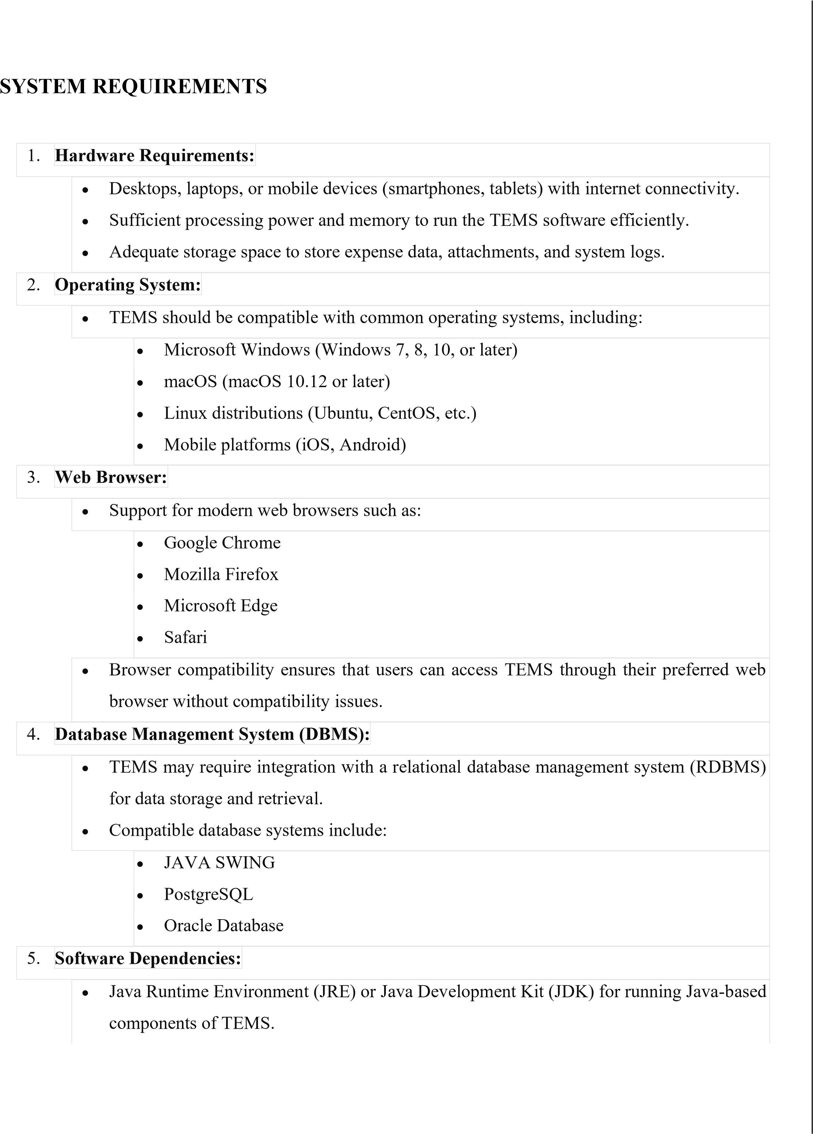

* Web server software (e.g., Apache Tomcat, Nginx) for hosting the TEMS application.
* Application frameworks and libraries used for development and runtime operations.

1. **Network Requirements:**
   * Stable internet connection with sufficient bandwidth to support TEMS operations.
   * Firewall and network security configurations to ensure secure data transmission and protection against cyber threats.
   * Support for HTTP/HTTPS protocols for web-based access to TEMS.
2. **Security Measures:**
   * Implementation of encryption protocols (e.g., SSL/TLS) to secure data transmission between clients and the TEMS server.
   * Role-based access control (RBAC) mechanisms to manage user permissions and restrict access to sensitive features and data.
   * Regular software updates and patches to address security vulnerabilities and protect against cyber attacks.
3. **Scalability and Performance:**
   * TEMS should be designed to scale according to the organization's needs, supporting a growing number of users, transactions, and data volumes.
   * Performance tuning and optimization to ensure responsive user experience and efficient system operation, even under heavy usage loads.
4. **Backup and Disaster Recovery:**
   * Implementation of backup and data recovery mechanisms to safeguard against data loss due to hardware failures, software errors, or other unforeseen events.
   * Regular data backups and testing of recovery procedures to ensure the integrity and availability of TEMS data.
5. **Documentation and Support:**
   * Comprehensive documentation covering installation instructions, system configuration, user guides, and troubleshooting procedures.
   * Access to technical support resources, including online helpdesk, knowledge base, and user forums, to assist users with system-related issues and inquiries.

## EXISTING WORK

|  |  |  |
| --- | --- | --- |
| 1.  2.  3.  4.  5.  6. | **Personalization** | : E-commerce businesses leverage customer data to personalize the shopping  experience. This includes product recommendations based on past purchases, browsing history, and demographic information. Personalized recommendations enhance customer satisfaction by showing relevant products, thus increasing the likelihood of conversion.  **Experience**: Providing a consistent experience across multiple channels,  including desktop, mobile, and brick-and-mortar stores (if applicable), ensures customers can interact with the brand seamlessly regardless of the platform they choose.  : Providing excellent customer support is paramount in e-commerce. This  includes offering multiple channels for communication such as live chat, email, and phone support. Quick response times and knowledgeable support agents contribute to a positive    : E-commerce businesses actively seek feedback from customers through  surveys, reviews, and ratings. Analyzing this feedback helps identify areas for improvement and allows businesses to address customer concerns promptly.  **and Shipping**: Efficient order processing, accurate order tracking, and  timely delivery are critical components of the e-commerce customer experience. Offering flexible shipping options, including expedited shipping and free shipping thresholds, can further tomer satisfaction.  **Refund Policies**: Transparent and hassle-free return and refund policies install trust  in customers and encourage them to make purchases. Clear communication about return procedures and a smooth refund process contribute to a positive overall experience. |
| **Omni-channel**  **Customer Support**  customer experience. **Feedback Collection Order Fulfillment**  enhance cus **Return and** |

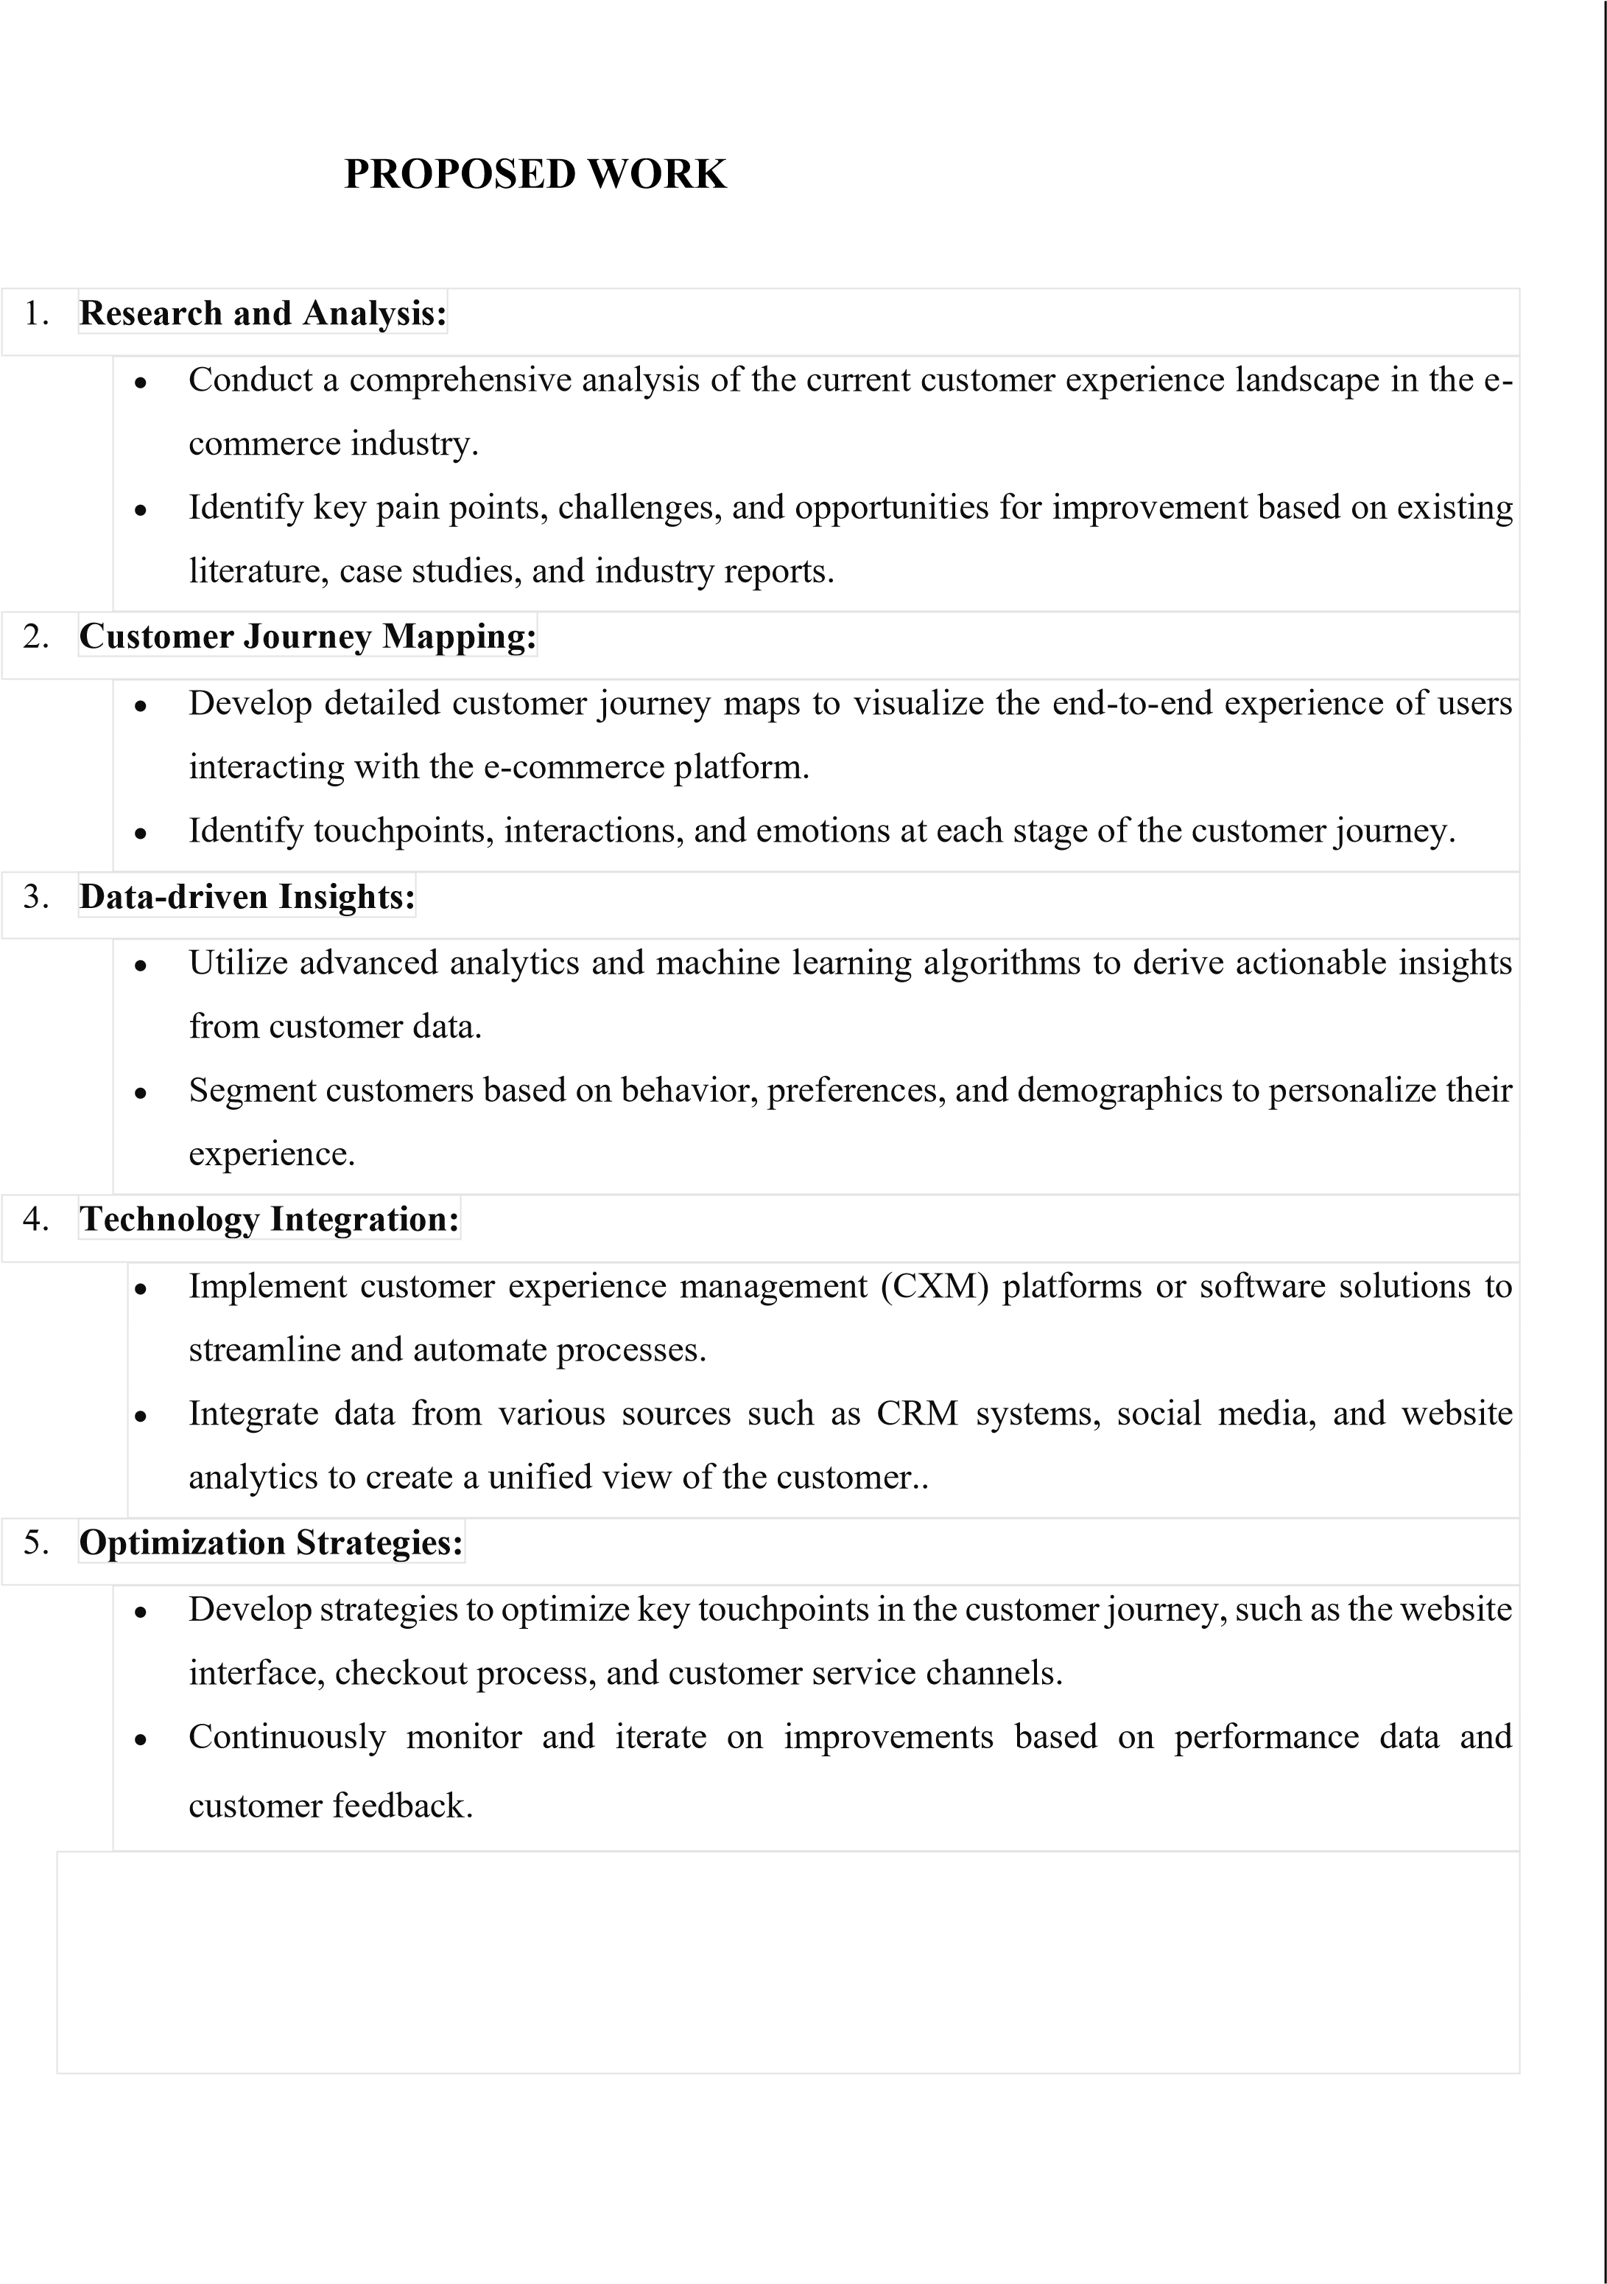

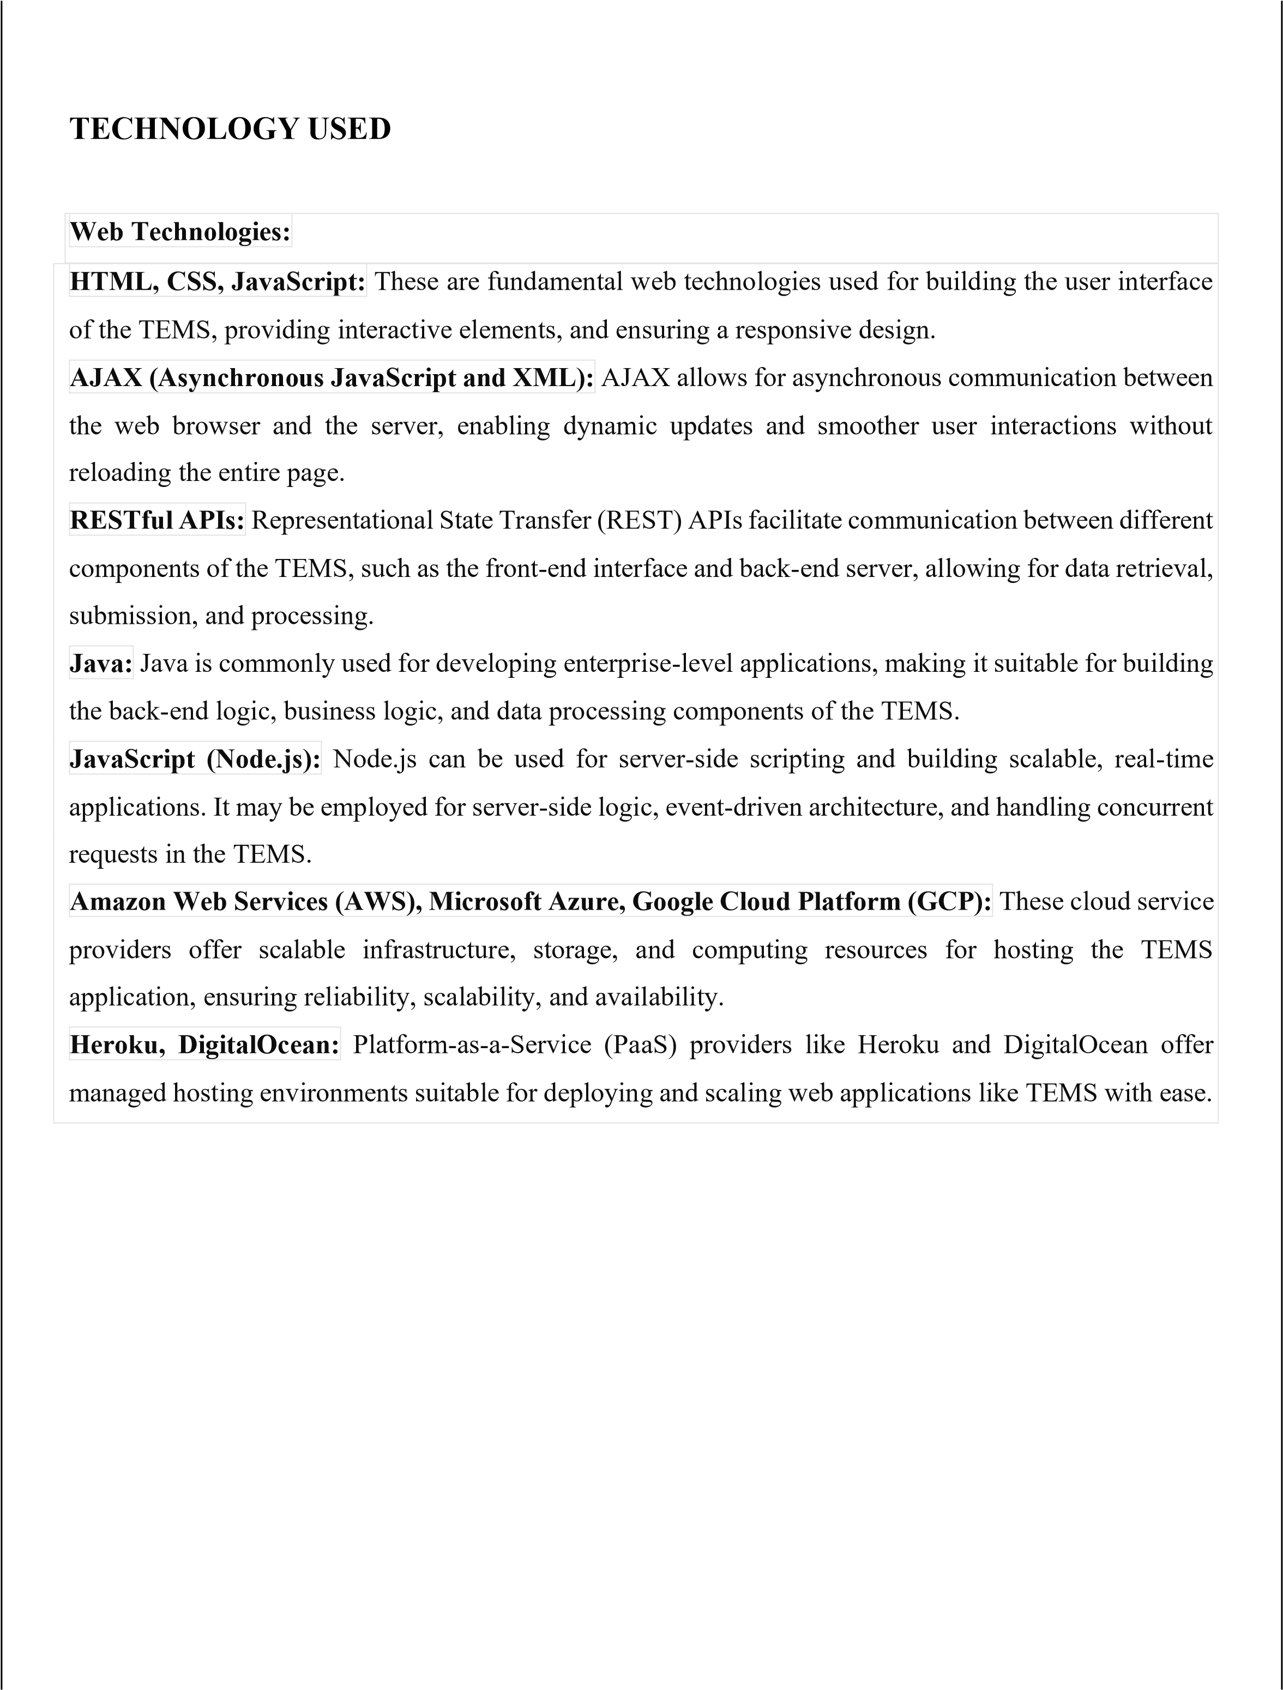

# *USE CASE DIAGRAM*

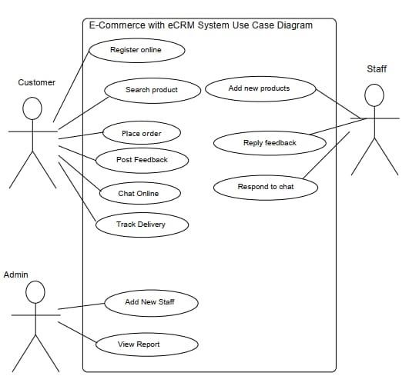

***SOURCE CODE*** import javax.swing.*; import java.awt.*; import java.io.FileWriter; import java.io.IOException; import java.util.ArrayList; import java.util.regex.Matcher; import java.util.regex.Pattern;

class Customer { private String name, email, experience, productLink;

public Customer(String name, String email, String experience, String productLink) { this.name = name; this.email = email; this.experience = experience; this.productLink = productLink;

}

public String getName() { return name; } public String getEmail() { return email; } public String getExperience() { return experience; } public String getProductLink() { return productLink; }

public void updateProductLink(String newProductLink) { this.productLink = newProductLink;

}

}

class CustomerExperienceManagementSystem extends JFrame { private ArrayList<Customer> customers = new ArrayList<>(); private JTextArea customerListTextArea; private JTextField nameField, emailField, experienceField, productLinkField; private JPanel panel;

public CustomerExperienceManagementSystem() { setTitle("Customer Experience Management System"); setSize(500, 400); setDefaultCloseOperation(JFrame.EXIT_ON_CLOSE); setLocationRelativeTo(null);

panel = new JPanel(new GridLayout(7, 2));

JLabel[] labels = {new JLabel("Name:"), new JLabel("Email:"), new JLabel("Experience:"), new JLabel("Product Link:")};

|  |  |  |
| --- | --- | --- |
| JTextField[] fields = {nameField = new JTextField(), emailField = new JTextField(), experienceField = new JTextField(), productLinkField = new JTextField()};    for (int i = 0; i < labels.length; i++) { panel.add(labels[i]); panel.add(fields[i]);  }    JButton addButton = new JButton("Add Customer"); addButton.addActionListener(e -> addCustomer()); panel.add(addButton);    customerListTextArea = new JTextArea();  JScrollPane scrollPane = new JScrollPane(customerListTextArea); panel.add(scrollPane);    add(panel); setVisible(true);  }    private void addCustomer() {  String name = nameField.getText(), email = emailField.getText(), experienceField.getText(),  15 | experience | = |

productLink = productLinkField.getText(); if (!isValidEmail(email)) { customerListTextArea.append("Invalid email address. Please enter a Gmail address.\n");

return;

}

if (!isValidLink(productLink)) { customerListTextArea.append("Invalid product link. Please enter a valid URL.\n");

return;

}

if (isDuplicateEmail(email)) { customerListTextArea.append("Duplicate email. This email already exists in the list.\n");

return;

}

Customer customer = new Customer(name, email, experience, productLink); customers.add(customer); updateCustomerList(); saveToCSV(customer);

clearFields();

}

private boolean isValidEmail(String email) {

String emailRegex = "^[a-zA-Z0-9_+&-]+(?:\\.[a-zA-Z0-9_+&-]+)*@gmail\\.com$";

Pattern pattern = Pattern.compile(emailRegex);

Matcher matcher = pattern.matcher(email); return matcher.matches();

}

private boolean isValidLink(String link) { String linkRegex = "^https?://.*$";

Pattern pattern = Pattern.compile(linkRegex); Matcher matcher = pattern.matcher(link); return matcher.matches();

}

private boolean isDuplicateEmail(String email) { for (Customer customer : customers) { if (customer.getEmail().equals(email)) {

return true;

} } return false;

}

private void updateCustomerList() { customerListTextArea.setText(""); for (Customer customer : customers) { customerListTextArea.append("Name: " + customer.getName() + ", Email: " + customer.getEmail() +

", Experience: " + customer.getExperience() + "\nProduct Link: " + customer.getProductLink() + "\n\n");

}

}

private void saveToCSV(Customer customer) { try (FileWriter writer = new FileWriter("customers.csv", true)) {

writer.append(String.join(",", customer.getName(), customer.getEmail(),

customer.getExperience(), customer.getProductLink()));

writer.append("\n"); } catch (IOException e) {

e.printStackTrace();

JOptionPane.showMessageDialog(this, "Error saving data to CSV file: " + e.getMessage(), "Error", JOptionPane.ERROR_MESSAGE);

}

}

private void clearFields() { nameField.setText(""); emailField.setText(""); experienceField.setText(""); productLinkField.setText("");

}

public static void main(String[] args) {

SwingUtilities.invokeLater(CustomerExperienceManagementSystem::new);

}

}

## SCREEN SHOTS(OUTPUTS)

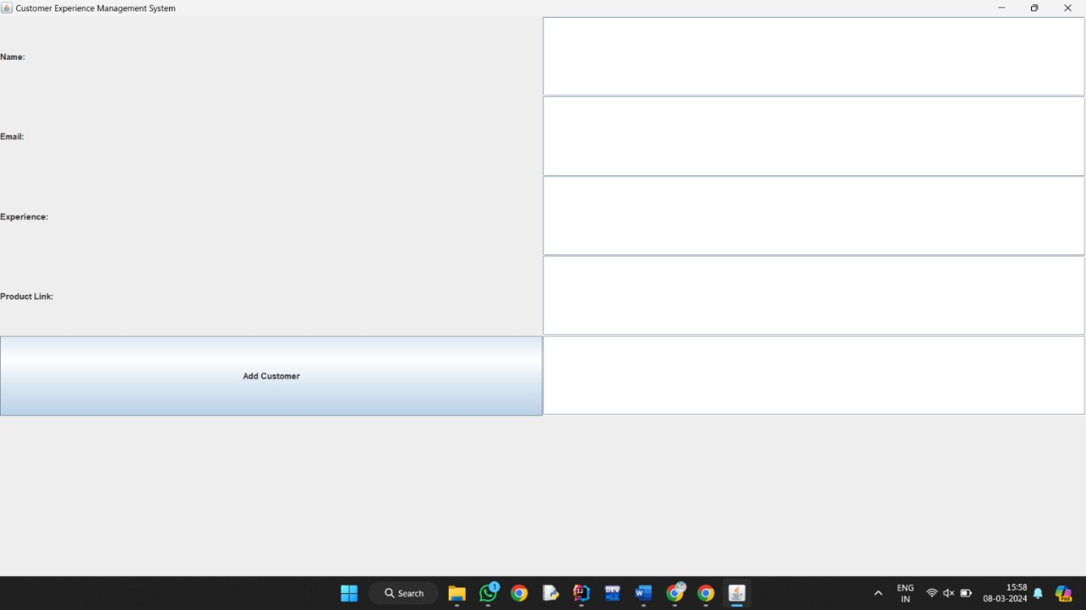

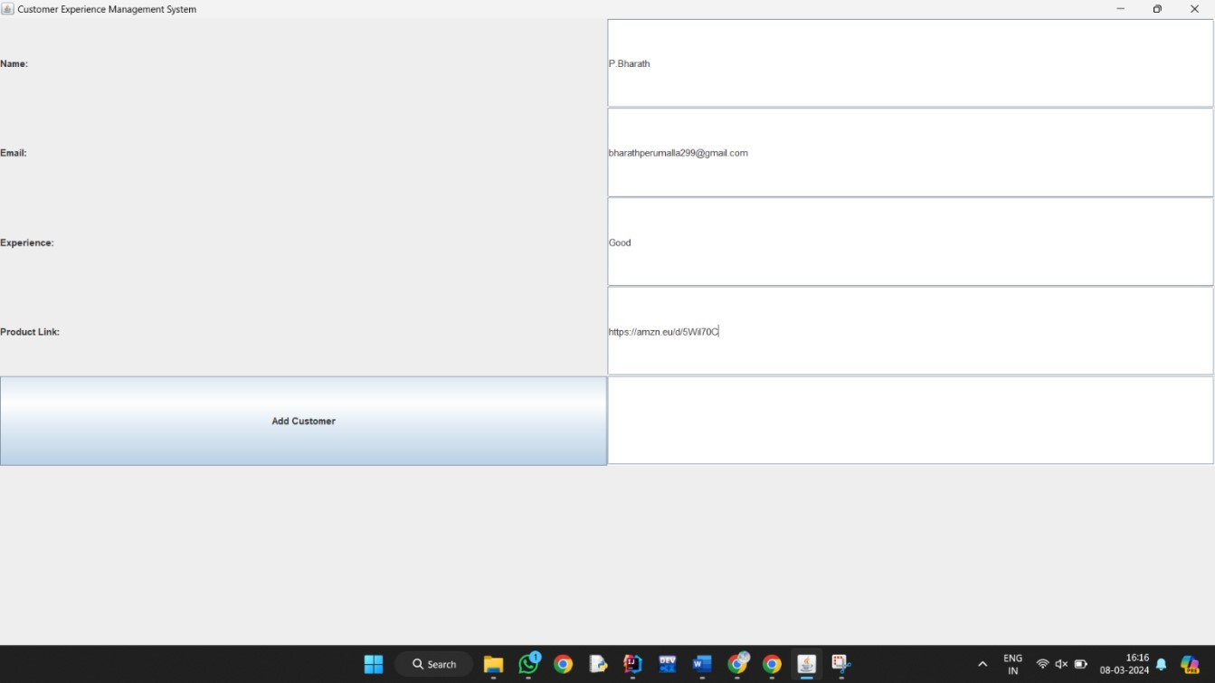

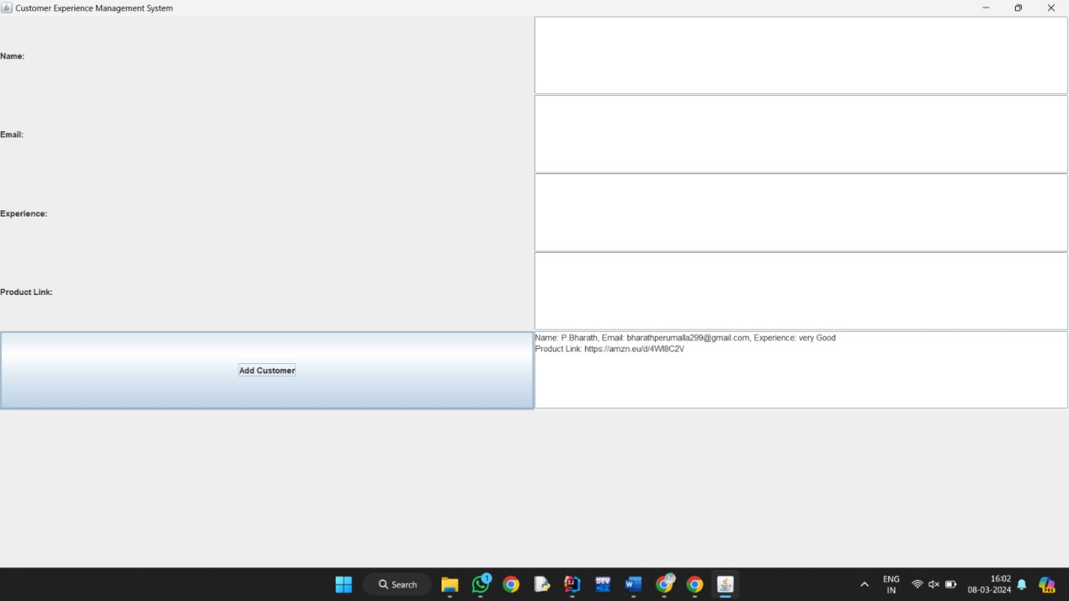

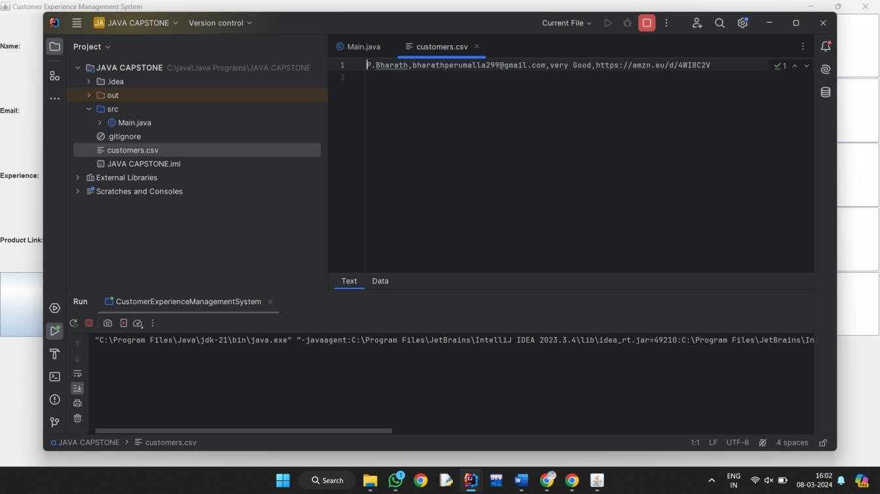

## CONCLUSION

* Customer Experience Management (CEM) stands as a critical pillar for the success of ecommerce businesses in today's highly competitive landscape. This conclusion sheds light on the indispensable role of CEM in fostering customer loyalty, enhancing brand reputation, and ultimately driving business growth.
* Firstly, e-commerce businesses must prioritize delivering seamless and personalized experiences across all touchpoints, from browsing to post-purchase interactions. By leveraging data analytics and AI-powered tools, businesses can gain valuable insights into customer preferences and behavior, allowing them to tailor offerings and communications accordingly.
* Secondly, proactive customer support and effective communication channels are essential components of CEM in e-commerce. Promptly addressing customer inquiries, concerns, and issues not only resolves immediate problems but also builds trust and loyalty over time. Implementing omnichannel support strategies ensures a consistent and cohesive experience regardless of the platform or device customers use.
* Furthermore, fostering a customer-centric culture within the organization is paramount. Every employee, from frontline staff to top management, should be committed to understanding and meeting customer needs. By prioritizing customer satisfaction and advocacy, e-commerce businesses can differentiate themselves in a crowded market and cultivate long-term relationships with their customer base.
* Lastly, continuous monitoring and optimization are necessary to adapt to evolving customer preferences and market dynamics. Regularly collecting feedback, analyzing performance metrics, and iterating on strategies enable businesses to stay agile and responsive, ensuring ongoing improvement in the overall customer experience.

### FUTURE ENHANCEMENT

|  |
| --- |
| Customer Experience Management (CEM) in e-commerce businesses is a critical aspect that directly |
| impacts customer satisfaction, retention, and ultimately, the success of the business. As technology continues to evolve and consumer expectations shift, e-commerce businesses must continuously enhance their CEM strategies to stay competitive and meet the evolving needs of their customers. |

|  |  |  |  |
| --- | --- | --- | --- |
|  | 1.  2.  3. | **Omni-Channel Integration:** | E-commerce businesses will increasingly focus on providing a  channel experience where customers can interact with the brand across multiple  touchpoints, including websites, mobile apps, social media, marketplaces, and physical stores. This ntegration requires synchronized data and communication channels to ensure consistency and    With the rise of smart speakers and virtual assistants, voice commerce commerce businesses. Enhancements in CEM will involve optimizing  -based search, product recommendations, and  enabled transactions while maintaining a personalized touch.  Augmented Reality (AR) and Virtual Reality (VR) technologies offer  immersive shopping experiences that enable customers to visualize products in real-world environments before making a purchase. Future enhancements in CEM will involve integrating  -commerce platforms to enhance product discovery, engagement, |
| seamless omni-  i continuity throughout the customer journey.  **Voice Commerce:**  presents a new frontier for ethe voice shopping experience, enabling voice seamless voice-  **AR and VR Experiences:**  AR and VR capabilities into e and satisfaction. |
|  | | | |

|  |
| --- |
| **REFERENCES** |
| 1. Che Jiuju. Research on the Collaborative Strategy of Electronic Commerce Corporation:The Framework and Case Study. 2010 Second International Conference on Communication Systems, Networks and Applications (ICCSNA 2010), 2010, vol. 2. 2. Ranzhe Jing, Yong Zhang. A Case Study on Imitative Innovation Strategy in Community E- |
| commerce. 2010 Information and Management Sciences--Processings of the Ninth International |
| Conference on Information and Management Sciences, 2010.   1. Atterer,Richard. Usability Tool Support for Model-based Web Development. Dissertation, LMU Munchen:Faculty of Mathematics, Computer Science and Statistics, 2008. 2. MSc in logistics and supply chain management: investigating the root cause of customer service inquiries in order to reduce service incidents, 2007. |

25